Hi Eren! I tried to split it into named NPC’s, stuff about her hunting community, stuff about her hunting practices then the backstory last. Everything but the hunting practices part is mainly just for flavour/fun tbh- I really only use the migration patterns as part of the backstory significantly. Sorry its so long and if it doesn’t work at all…

Sialis- Sialia's younger sister. Robin's aunt and maternal figure. (alive)

Haddock- Robin's father. Guardian of Piscium order (alive)

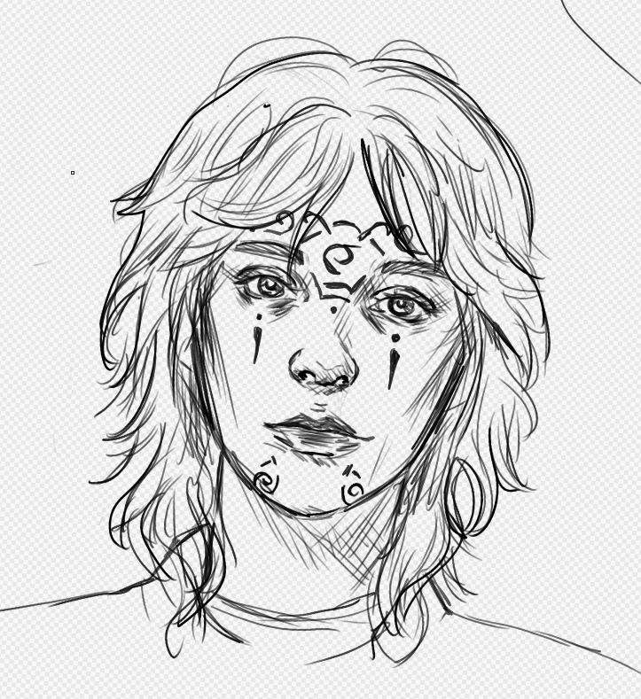Sialia- Robin's mother. Sialis's big sister. (dead)

Robin's first name comes from her mother Sialia (Bluebird genus) who's part of the Avian order and her last name Haddock is her father's who’s the guardian of the Piscium order.

**Hunting community name: saltuarius:** This term can mean a forest warden in neo-latin

**Saltuarius organization**

Seasonally semi-sedentary hunter-gatherer-forager (HGF) community of around 15-20 members. Communal, horizontal social complexity meaning that power isnt centralized and heirarchical but egalitarian power distribution based on specialization/talents.

4 orders based on proficiencies and characteristics

Avian (bird): agile and acrobatic. Observers from a distance due to fragility but delivers precise attacks when they swoop in. Tend to be proficient in ranged.

Piscium (fish): quick and alert. Able to go with the flow and survive off little sustenance. Tend to be proficient fishers, aquatic foragers and anything to do with water (navigating, filtering, boating)

Cervidae (deer/moose/elk): defensive tanks that are able to travel long distances and herd the rest of the community. Need more resources than other clans but tend to be proficient in land foraging.

Canis (wolf/dog): frontline hunters that track down prey when they loose sight/no visual traces to follow. Tend to specialize in melee.

 Guardian: strongest/most proficient member of each order. Teaches, guides and protects each clan. Called guardian and not necessarily a leader because of horizontal corporate social complexity.

**Saltuarius hunting practices**

The Saltuarius primarily hunt in the Forlornwoods. Their practice is to sustainably harvest an area, maintaining ecological balance by targeting overpopulated or invasive species while sparing the young and breeding individuals of native populations.

They are nomadic, moving between hunting camps and staying near established settlements. When they have accumulated a surplus of game and foraged goods, or need supplies they cannot procure themselves, they travel to King's Stand to trade.

Their most significant journey is the annual Migration: a fall expedition to the SPQU capital that tests their community's skills and resilience. They hunt, forage, and trade along the way, preserving resources between stops. The journey culminates upon reaching the capital. They then spend the winter in one of those main SPQU provinces that requires their services, as their nomadic lifestyle is unsustainable during that season.

**Saltuarius values and beliefs**

Generally agnostic as a community but individuals may belive in the Eight or elven beleifs

Nature is lawless but balanced and those with consiousness and intelilgence bear a greater responsibility to maintaining that balance than creatures only concerend about survival

Nature is lawless and not meant to be owned or contained- a borderless perspective of the world is the best way to navigate it

All living things have a desire to survive which is just, but cannot justify actions universally. Seeking understanding before passing judgment maintains balance.

Needless excess is hindrance and theft. Nature is lawless but always will provide.

**Robin backstory**Childhood:

Sialia, Robin’s mother, dies during childbirth—a common tragedy in their nomadic hunter-gatherer society. Due to epigenetics, bad luck, and complications, Robin is born very frail.

Sialis, Robin’s aunt, helps Haddock care for the infant and grows attached as Robin begins to resemble her late sister. Robin’s frailty leads to frequent illness and an inability to safely practice hunting or foraging, making her a growing resource drain as she ages. She understands the necessary skills but cannot contribute consistently. She is often left at camp as the group requires all hands to cover the resource deficit.

During the fall Migration when Robin is 5 she gets fatally ill towards the end. Usually they treat it with their own herbal medicines and practices or find a local healer but in cases of emergency (like this one) they will turn to church healers- especially in the main SPQU provinces where (I assume) they have better infrastrucure and practices for healthcare

Her long recovery makes Sialis realize the situation is unsustainable. That spring, Sialis joins the Kings Stand militia, aiming to climb to a professional post in the SPQU capital. This provides stable income to support Robin and repays the city that saved her niece.

While Robin travel's a lot she cannot explore the areas she travels too- looks at the world through a keyhole. the present was too dangers to go out and explore so the only ting she would have to satisfy her curiosity is exploring past material histories (Ie archaeology graves ect) or talking to/learning form peopel who could go out and live freely in the present. Robin satisfies her curiosity by intensely studying the natural world and local history within her limited safe radius, including lore about elven ghosts. She practices hunting skills religiously, hoping to one day contribute and make Sialis proud. Before Sialis rises the ranks and leaves the Forlornwoods she would take care of Robin and tell her stories whenever they had the chance to meet.

Adulthood:

Around 19 she is able to join hunts and even does the fall migration that year to the capital of SPQU without falling too ill. That winter, they find Sialis has changed, adopting soldierly SPQU values: a hierarchy of species, a belief that nature must be governed, and hunting for sport. This influence begins to sway some in the community over subsequent visits, a mindset Robin cannot understand.

At 20, Robin is a full contributor and expects Sialis to rejoin them. Instead, Sialis, now loyal to SPQU, tries to hire the Saltuarius as militia under her command, arguing instead of having to HGF for a living just use the same skills to serve Ultland and its people. Sialis cares a lot about community Saltuarius and Ultland and has hear that Some influential people within the republic think arcane magic is the only way for Utland to unite all humanity under one banner, and alf stones are a necessity for that.

Some members are swayed, but Robin pleads with Sialis to return. Sialis refuses, stating her duty is now in the provinces since Robin is able to hunt now and her skills are more needed here. This pattern repeats for two years, with Sialis pressuring them to join the King's Stand militia to defend against non-humans and potentially retake Greenfort. When Robin is 23, Sialis is convinced that there is a reason why Ard Caed sealed Greenfort and that something in there will be key to helping and uniting humanity and while they still weild a bow they are a fully fledged soldier at heart

Pre-campaign:

The following summer, Lord Vincentas falls ill, and the Sialis-swayed members enlist in the militia. This leaves the Saltuarius too shorthanded for long hunts, trapping them near Kings Stand. Staying put forces overhunting, violating their values, and pushes them toward a sedentary lifestyle.

Robin feels responsible, as Sialis’s initial enlistment was due to her childhood illness. Her attempts to reason with the enlistees or Sialis fail; they dismiss her due to her sheltered past.

To save Saltuarius from disbanding and convince Sialis to return to their values, Robin embarks on her own adventure. Her goals are to:

Prove her world knowledge and experience.

Understand past and present events (the War of Flames, Alf Trees, etc.) to find evidence to change Sialis's mind.

Enter Greenfort before Sialis can, using her discovery to either redeem her aunt or stop her if she is irredeemable.

Noah and I were also thinking about having some connection via our backstory but if its not possible don’t worry!! We just thought the parallels between our characters with Robin and Tommen being sheltered in opposite environments were a fun coincidence to play around with- the two of them may not even remember/know about the other but there could be a link in backstories?? The only areas that we could think of to connect is the winters in the SPQU main provinces or Robins aunt Sialis who becomes a more hardcore soldier……. (if you think her whole character is even possible to begin with….)